IT Neural Network Self-Driving Report

Explanation of Code 1

Explanation of the Main function (line 255) (3 Marks) 2

Explanation of the Simulation function (line 165) (6 Marks) 2

Explanation of the Car class (line 30) (6 Marks) 2

Impact of Population Size on Efficiency in Training Autonomous Cars 2

How does the population of the simulation affect the training speed of the program? 3

Introduction: 3

Methods: 3

Results: 3

Discussion: 4

Conclusion: 4

Referencing: 5

# Explanation of Code

## Explanation of the Main function (line 255) (3 Marks)

## Explanation of the Simulation function (line 165) (6 Marks)

## Explanation of the Car class (line 30) (6 Marks)

# Impact of Population Size on Efficiency in Training Autonomous Cars

## How does the population of the simulation affect the training speed of the program?

|  |  |  |  |
| --- | --- | --- | --- |
| Population Size | Time Taken (seconds) | Amount of Generations | Map |
| 10 | 13.33 | 3 | 2 |
| 20 | 38.85 | 7 | 2 |
| 50 | 29.62 | 4 | 2 |
| 100 | 21.68 | 3 | 2 |

This scientific report explores how the population of AI-driven cars influences their training efficiency. An experiment was conducted with different population sizes (10, 20, 50, and 100) to see if more cars would allow the program to learn faster.

Measurements were taken to display how long it took for these cars to complete a lap in a computer simulation. The findings suggest that having more cars doesn't make them finish laps faster, but it does help pick the cars with the best fitness more effectively.

## Introduction:

Teaching AI to drive cars is vital for self-driving vehicles. I wanted to see if having more cars to learn from would make them learn quicker. I used a python-based computer program to test this idea.

## Methods:

I ran several tests in this python-simulation. I changed the population of cars in each test:10, 20, 50, and 100. I measured how long it took for a car to finish a lap.

## Results:

|  |  |  |  |
| --- | --- | --- | --- |
| Population Size | Time Taken (seconds) | Amount of Generations | Map |
| 10 | 13.33 | 3 | 2 |
| 20 | 38.85 | 7 | 2 |
| 50 | 29.62 | 4 | 2 |
| 100 | 21.68 | 3 | 2 |

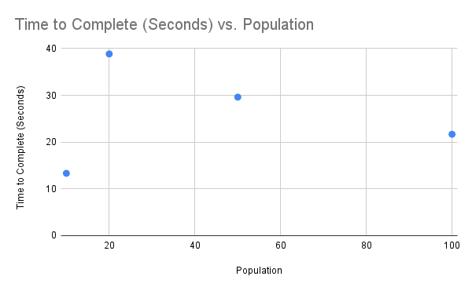

## Discussion:

The results show that having more cars in the learning group did not make them complete laps faster. Lap times were relatively similar in all tests, with some outliers, like the 10 and 20 population tests, but, having a higher population of cars did help in other ways:

* Variability and Strange Behavior: In tests with fewer cars (10 and 20), some cars acted oddly, leading to longer lap times. Fewer cars meant less variety in learning.
* Better Performance and Consistency: With more cars (50 and 100), performance was more stable, and there were fewer odd behaviours. More cars meant a larger group to choose the best cars from.

## Conclusion:

In conclusion, having more cars in the simulation did not make them finish laps faster. However, having more cars helped in other ways. It made the learning process more stable, reduced odd behavior, and made the results more reliable, so while more cars may not make learning faster, they do help in picking the fittest cars, due to the larger selection pool.

## Referencing:

* Www-Liby@waikato.ac.nz (no date) Writing a scientific report, Write Scientific Reports - The Library: University of Waikato. Available at: https://www.waikato.ac.nz/library/guidance/guides/write-scientific-reports (Accessed: 11 September 2023).